SESSION 17
Introduction to Regression
Simple Linear Regression: Assignment Notes with Worked Demo

1. Dependent vs Independent Variable

1.1 What is regression?
Regression analysis models the relationship between variables so that we can explain one variable using another and make predictions. Simple linear regression uses exactly one independent variable and fits a straight line to the data.

1.2 Types of variables
Term | Meaning | Example (this session)
Independent variable (X) | The input or predictor used to explain or predict the outcome. Also called the explanatory variable or feature. | Advertising spend
Dependent variable (Y) | The outcome we want to predict or explain. Also called the response or target variable. | Sales

Y depends on X, not the other way round. Choosing which variable is X and which is Y depends on the question being asked: "Can advertising spend predict sales?" makes sales the dependent variable.

1.3 Regression vs correlation
- Correlation: measures the strength and direction of a relationship, and treats both variables equally.
- Regression: gives an equation that predicts Y from X, and treats X and Y differently.

2. Line of Best Fit

2.1 The simple linear regression equation
ŷ = b0 + b1 × X
- ŷ (y-hat): the predicted value of the dependent variable.
- b0 (intercept): the predicted value of Y when X = 0.
- b1 (slope): the change in predicted Y for a one-unit increase in X.

2.2 Least squares method
Many lines could be drawn through a scatter of points. The line of best fit is the one that minimises the sum of the squared residuals. A residual is the difference between an actual value and the predicted value (e = y − ŷ). This is called the method of ordinary least squares (OLS).
Minimise SSE = Σ (y − ŷ)²

2.3 Formulas for the coefficients
b1 = Σ(x − x̄)(y − ȳ) / Σ(x − x̄)²
b0 = ȳ − b1 × x̄
The fitted line always passes through the point (x̄, ȳ), the mean of X and the mean of Y.

2.4 Example
Question: Find the line of best fit for x = 1, 2, 3, 4, 5 and y = 2, 4, 5, 4, 5.
Solution: x̄ = 3 and ȳ = 4. Deviations of x: −2, −1, 0, 1, 2. Deviations of y: −2, 0, 1, 0, 1.
- Σ(x − x̄)(y − ȳ): 4 + 0 + 0 + 0 + 2 = 6
- Σ(x − x̄)²: 4 + 1 + 0 + 1 + 4 = 10
- Slope: b1 = 6 / 10 = 0.6
- Intercept: b0 = 4 − 0.6 × 3 = 2.2
ŷ = 2.2 + 0.6 X
Prediction: for x = 6, ŷ = 2.2 + 0.6 × 6 = 5.8.

3. Coefficients Interpretation

3.1 Slope (b1)
The slope tells us how much Y is expected to change when X increases by one unit. A positive slope means Y rises with X; a negative slope means Y falls as X rises.
Template: "For every one-unit increase in [X], [Y] is predicted to change by [b1] units, on average."

3.2 Intercept (b0)
The intercept is the predicted value of Y when X is zero. It is meaningful only if X = 0 is realistic and lies within the range of the data. Otherwise it is just the point where the line crosses the Y-axis.

3.3 Interpretation example
For the line ŷ = 2.2 + 0.6 X above: each one-unit increase in X is associated with an average increase of 0.6 units in Y. When X = 0 the predicted Y is 2.2.

3.4 Important cautions
- Association, not causation: a slope does not prove that X causes the change in Y.
- Avoid extrapolation: predictions are reliable only inside the range of X values used to build the model.
- Always plot the data: a straight line is suitable only if the relationship looks roughly linear.

4. R-squared (Coefficient of Determination)

4.1 Definition
R-squared (R²) is the proportion of the variation in Y that is explained by the regression on X. It ranges from 0 to 1 (0% to 100%).
R² = 1 − SSE / SST
- SSE (error sum of squares): Σ(y − ŷ)², the variation left unexplained by the line.
- SST (total sum of squares): Σ(y − ȳ)², the total variation in Y around its mean.
In simple linear regression, R² equals the square of the Pearson correlation coefficient: R² = r².

4.2 Interpreting R-squared
R-squared | Interpretation
Close to 1 | The line explains almost all the variation in Y, so it is a very good fit.
About 0.5 | The line explains about half of the variation; other factors matter too.
Close to 0 | The line explains very little; X is not a useful predictor of Y.

4.3 Example
For the small example above, r = 0.775, so R² = 0.775² = 0.60. The model explains 60% of the variation in Y; the remaining 40% is due to other factors or random variation.

4.4 Limitations
- A high R² does not prove that the model is correct or that X causes Y.
- A low R² is not always bad; in fields such as human behaviour, values are often low.
- Check residual plots as well, since R² cannot detect a curved pattern.

5. Fitting a Regression in Python
With scikit-learn, the workflow has four steps:
- Step 1: prepare X as a two-dimensional array (reshape(-1, 1)) and y as a one-dimensional array.
- Step 2: create the model with LinearRegression().
- Step 3: train it using model.fit(X, y).
- Step 4: read model.intercept_ and model.coef_, predict with model.predict(), and compute R² with r2_score().

6. Demo: Predict Sales Based on Advertising Spend

6.1 Problem statement
A company recorded advertising spend and sales (both in Rs. thousand) for 10 periods. Build a simple linear regression model to predict sales from advertising spend, interpret the coefficients, and check how well the model fits. The figures are illustrative for this demo.

6.2 Data
Advertising spend (X): 10, 15, 20, 25, 30, 35, 40, 45, 50, 55
Sales (Y): 95, 120, 135, 165, 170, 205, 215, 250, 255, 290

6.3 Python code
import numpy as np
import matplotlib.pyplot as plt
from sklearn.linear_model import LinearRegression
from sklearn.metrics import r2_score

# Advertising spend and sales (in Rs. thousand) - illustrative
ad_spend = np.array([10, 15, 20, 25, 30, 35, 40, 45, 50, 55])
sales = np.array([95, 120, 135, 165, 170, 205, 215, 250, 255, 290])

X = ad_spend.reshape(-1, 1) # independent variable (2-D)
y = sales # dependent variable

# Fit the line of best fit
model = LinearRegression()
model.fit(X, y)

b0 = model.intercept_
b1 = model.coef_[0]
y_pred = model.predict(X)
r2 = r2_score(y, y_pred)

print("Intercept (b0):", round(b0, 2))
print("Slope (b1):", round(b1, 2))
print("R-squared:", round(r2, 4))
print("Predicted sales for ad spend = 42:", round(model.predict([[42]])[0], 2))

# Scatter plot with regression line
plt.scatter(ad_spend, sales, label="Actual data")
plt.plot(ad_spend, y_pred, color="red", label="Line of best fit")
plt.xlabel("Advertising spend (Rs. thousand)")
plt.ylabel("Sales (Rs. thousand)")
plt.title("Sales vs Advertising Spend")
plt.legend()
plt.show()

6.4 Output
Intercept (b0): 53.7
Slope (b1): 4.19
R-squared: 0.9898
Predicted sales for ad spend = 42: 229.84

6.5 Regression line
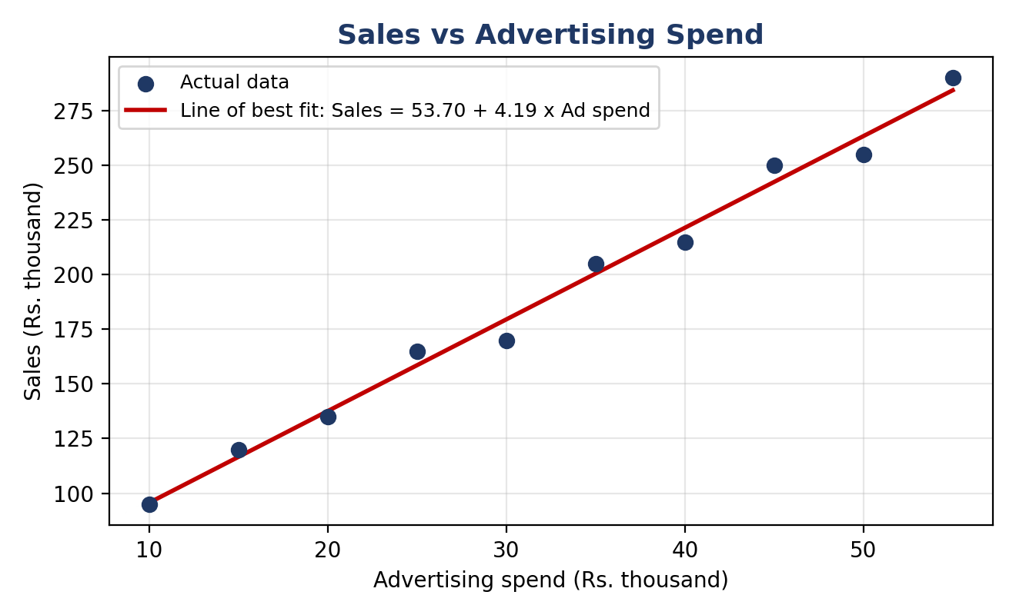
Figure 1: Scatter plot with the line of best fit

6.6 Fitted equation
Sales = 53.70 + 4.19 × Advertising spend

6.7 Interpretation
- Slope (4.19): for every additional Rs. 1 thousand spent on advertising, sales are predicted to increase by about Rs. 4.19 thousand, on average.
- Intercept (53.70): with no advertising, predicted sales are about Rs. 53.7 thousand. Since X = 0 is outside the observed range (10 to 55), treat this only as the starting point of the line.
- R-squared (0.9898): advertising spend explains about 99% of the variation in sales, so the line fits the data very well. This matches r = 0.995 between the two variables.
- Prediction: for an advertising spend of Rs. 42 thousand, predicted sales = 53.70 + 4.19 × 42 ≈ Rs. 229.84 thousand. This value lies inside the data range, so it is reliable.
- Caution: predicting for spends far beyond Rs. 55 thousand would be extrapolation, and the relationship may not stay linear. The result also shows association, not proof that advertising alone causes sales.

Key Takeaways
- Variables: X is the independent (predictor) variable and Y is the dependent (outcome) variable.
- Line of best fit: ŷ = b0 + b1X, found by minimising the sum of squared residuals.
- Coefficients: b1 is the change in Y per one-unit increase in X; b0 is the predicted Y when X = 0.
- R²: the proportion of variation in Y explained by X (in simple regression, R² = r²).
- Python: LinearRegression().fit(X, y) gives the coefficients, and predict() gives forecasts.

